林振汶 Ling Chin Ung,  📞 +65 8915 5937 | 📧 jasonling23@yahoo.com,  🔗 LinkedIn | 💻 GitHub | 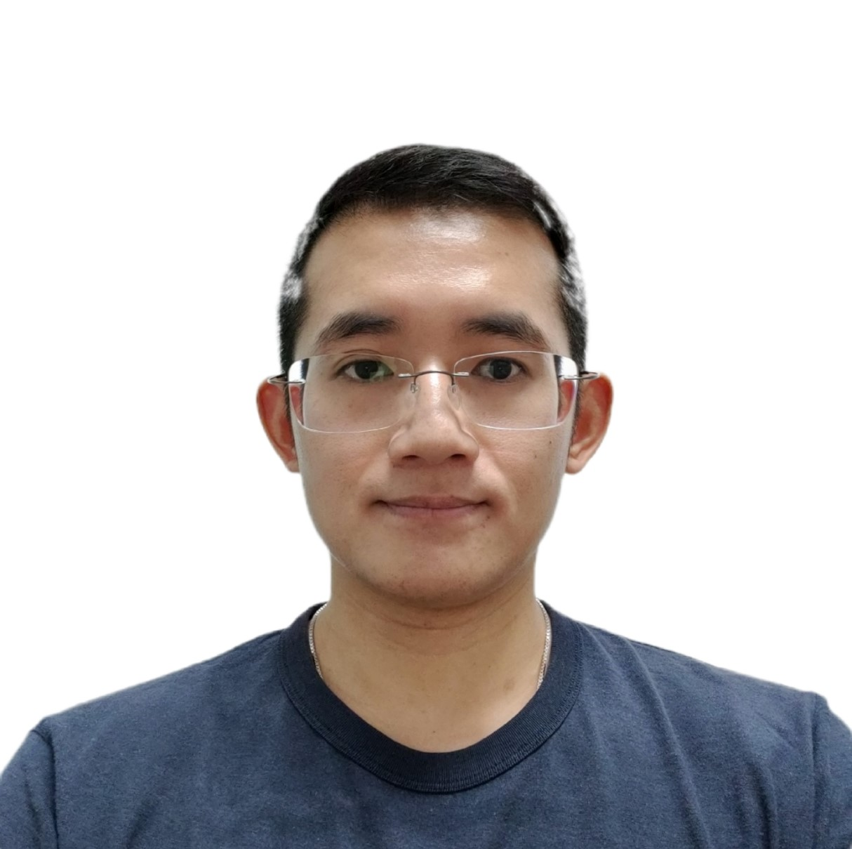
Career Objective
Aspiring Data Scientist with 15+ years of experience as a Retail Pharmacist, specializing in operations, inventory optimization, and regulatory compliance. Recently graduated from the Data Science & AI Bootcamp at Le Wagon Singapore (September 2025). Skilled in Python, SQL, and machine learning, with strong domain expertise in healthcare and retail. Seeking to apply data-driven solutions in AI, data science, or ML engineering roles.

Projects
Olist Seller Profitability Optimization (Le Wagon, Singapore · 2025)
- Performed exploratory data analysis (EDA) on Olist e-commerce dataset to identify non-profitable sellers.
- Recommended removal of 800+ sellers with zero or negative profit, projected to save company ~$300K annually while maintaining $1.1M net profit.
- Tools: Python, Pandas, Seaborn, Matplotlib | 💻 GitHub

Breast Cancer Classification with Mammogram Images (Le Wagon, Singapore · 2025)
- Developed a deep learning model using ResNet CNN with transfer learning (ImageNet weights) on the CBIS-DDSM mammogram dataset (Kaggle) to classify breast cancer cases into benign vs. malignant.
- Applied data preprocessing, distribution visualization, and image augmentation to improve model robustness and generalization.
- Fine-tuned and validated the model, achieving high classification accuracy, supporting potential early breast cancer detection.
- Tools: Python, TensorFlow/Keras, Pandas, Matplotlib, Seaborn, LangChain | 💻 GitHub

Stock Price Prediction and Analysis (LSTM · XGBoost · Streamlit)
- Developed and deployed an end-to-end stock price forecasting system using historical CSPX (S&P 500 ETF) data.
- Engineered financial features (moving averages, returns, volatility, lags, cyclical encodings) to enhance predictive performance.
- Compared models (LSTM, XGBoost) with error and residual analysis, achieving 135% R² improvement over baseline.
- Built and deployed an interactive Streamlit dashboard for real-time stock predictions and model performance visualization.
- Tools: Python, TensorFlow/Keras, Scikit-learn, XGBoost, Streamlit | 💻 GitHub
Technical Skills
Programming: Python, SQL, Git, APIs
Libraries & Frameworks: Pandas, NumPy, Scikit-learn, Seaborn, Matplotlib, TensorFlow, Keras, PyTorch (basic)
ML/AI Models: Linear & Logistic Regression, Decision Trees, Random Forest, Clustering, Convolutional Neural Networks (CNNs), Transfer Learning (EfficientNet, ResNet), Gradient Boosting (XGBoost, LightGBM), Recurrent Neural Networks (RNNs), LSTM, GRU for time series forecasting
MLOps & Workflow Tools: Google Colab, Jupyter Notebook, GitHub, Streamlit, Tableau (basic), MLflow (experiment tracking), Docker (basic), Hugging Face Transformers (basic), Google Cloud Platform (GCP)
AI Agent & Generative AI Tools: ChatGPT, Claude (prompt engineering, workflow automation, prototyping)
Strengths: Strong analytical thinking, cross-functional leadership, experience in regulated environments (GxP, ISO 27001)
Language
English (Fluent), Chinese (Fluent), Malay (Fluent)
Certifications
2260360, Certified in Planning & Inventory Management — Association for Supply Chain Management (Sep 2021)
P02604B, Registered Pharmacist — Singapore Pharmacy Council (since 2012)
011827, Registered Pharmacist — Malaysia Pharmacy Board (since 2014)
Experience
Assistant Pharmacy Manager
Guardian Health & Beauty, Singapore — March 2023 – Present
- Analyzed store sales and trends to improve stock rotation and reduce wastage.
- Oversaw daily store operations including manpower planning, inventory checks, and execution of promotional activities aligned with business targets.
- Ensured regulatory compliance and trained team on SOPs and data recording.
Business Owner & Pharmacist
Wja Trading Sdn Bhd (aka b-well pharmacy), Malaysia — July 2017 – December 2022
- Increased revenue by 20% using data-driven stock analysis.
- Reduced loss by 75% via inventory management and waste analysis.
- Handled full business ops including sales, HR, finance, procurement.
QA and Regulatory Pharmacist
Zuellig Pharma Specialty Solution Group, Singapore — June 2014 - April 2016
- Handled quality batch release and documentation review for secondary packaging products.
- Managed SAP-based stock and license data, helped implement ISO 27001.
- Processed and tracked compliance for restricted products and psychotropics.

Outpatient Pharmacist & Inventory Phamarmacist
Tan Tock Seng Hospital, Singapore September — 2011 - February 2014
- Supervised dispensing and patient education.
- Managed special inventory drugs and liaised with pharma suppliers.

Education
Le Wagon Data Science & AI Bootcamp
Singapore — (July 2025 - September 2025)
Intensive program covering Python, SQL, machine learning, deep learning, time series, APIs, and project deployment.
Master of Pharmacy (Mpharm) – Honours 2:1
The University of Manchester (September 2007 – July 2011)

Interest
Snowboarding, Surfing, Swimming, Wakeboarding, Gym, Scuba Diving, Flowriding, PC Building

